Purpose

The following checklist identifies important Remedial Action Scheme (RAS) information for each new or functionally modified RAS that the RAS entity must document and provide to the reviewing Reliability Coordinator(s) (RC). If an item on this list does not apply to a specific RAS, a response of “Not Applicable” for that item is appropriate. When a RAS is submitted for functional modification review and approval, only the proposed modifications to that RAS require review; however, the RAS entity must provide a summary of the existing functionality. The RC may request additional information on any aspect of the RAS as well as any reliability issue related to the RAS. Additional entities (without decision authority) may be part of the RAS review process at the request of the RC.

Review Scope

The RC West review will focus on compatibility and inter-dependencies with other RAS operation and other protection and control systems, which could result in inconsistencies or conflicts in emergency situations. The review scope will focus on RAS operations with adjacent entities and adjacent RCs. The RAS entity is responsible to denote impacts to adjacent entities in the checklist.
The RC is the best-suited functional entity to perform the RAS review due to its wide area reliability perspective of all functional entities and awareness of reliability issues in neighboring RC Areas. The Wide Area purview better facilitates the evaluation of interactions among separate RASs, as well as interactions among RASs and other protection and control systems. The selection of the RC also minimizes the possibility of a conflict of interest that could exist because of business relationships among RAS entities, Planning Coordinators, Transmission Planners, or other entities involved in the planning or implementation of a RAS. The RC is also less likely to be a stakeholder in any given RAS and can therefore maintain objective independence.

RAS Review Process

The RAS entity will submit all the required documentation for RC West review and in accordance with the submission checklist.
Upon completion of the RC West review process, the RC will post review results to the RC Portal and notify the submitter via the notification system or email from isorc@caiso.com. Email will be used as a backup to the RC Portal. If the submitter is coordinating with other RAS entities, a separate review letter will be posted for each entity.
Be advised that any Remedial Action Scheme (RAS) information submitted by a RAS entity into the RC Portal is considered confidential and is protected by the terms and restrictions set forth in the Western Interconnection Data Sharing Agreement (WIDSA). By submitting RAS Information into the RC Portal, the RAS entity represents that it is a signatory to the WIDSA and that it agrees to abide by the terms and conditions of the WIDSA with respect to its review or use of any confidential RAS information in the portal. Persons accessing the RAS information in the RC Portal assume full responsibility for the use of the information and understand and agree that the California Independent System Operator (CAISO or "ISO") is not responsible or liable for any claim, loss, or damage arising from the use of such information.
The figure below illustrates the review timeline process including submittal of RC0690A, which is the Attachment 1 and 2 with supporting documentation. It also includes the review timeline process with respect to WECC RASRS and modeling information.

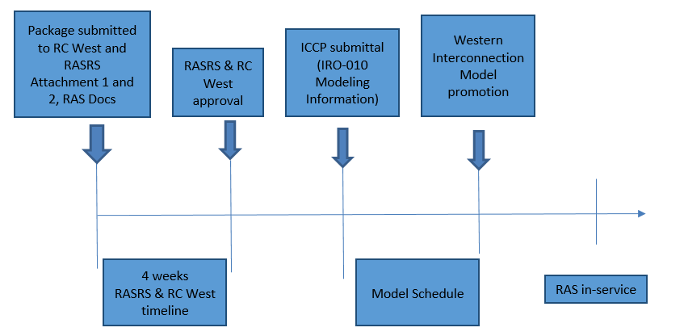
Figure 1: RAS Review Timeline

Submittal Checklist – Attachment 1
Any information that is not applicable shall be marked as such in the “Applicable to this Criterion (Yes or No)” columns below. This form reflects the requirements outlined in Attachment 1 of PRC-012-2.
Pages and references to attached documents are acceptable in the fields where description are required. The RAS entities should submit the following documents to RC West for a new RAS, modification to a RAS, or RAS retirement:
- Information such as maps, one-line drawings, substation and schematic drawings that identify the physical and electrical location of the RAS and related facilities.
- Functionality of a new RAS or proposed functional modifications to an existing RAS and documentation of the pre- and post-modified functionality of the RAS.
- The Corrective Action Plan (CAP) if RAS modifications are proposed in a CAP.
- A summary of technical studies, if applicable, demonstrating that the proposed RAS actions satisfy System performance objectives for the scope of System events and conditions that the RAS is intended to remedy. The technical studies summary shall also include information such as the study year(s), System conditions, and Contingencies analyzed on which the RAS design is based, and the date those technical studies were performed.

List all the supporting documentation provided with this submission  (Insert rows if needed) | Title | Version | Effective Date | Included with this submission? (Yes/No)
Date Submitted:
Name:
Title:
Department:
Phone:
Email Address:
Lead RAS Entity
Other RAS Entities
RAS Identifier
Specify RAS Entity applicability:  Transmission Owner, Generator Owner, or Distribution Provider that owns all or part of a RAS. | Mark as applicable  TO GO DP

General

Criteria | Applicable to this Criteria?  (Yes or No) | Notes
- Information such as maps, one-line drawings, substation and schematic drawings that identify the physical and electrical location of the RAS and related facilities.
- Functionality of new RAS or proposed functional modifications to existing RAS and documentation of the pre- and post-modified functionality of the RAS.
- The Corrective Action Plan (CAP) if RAS modifications are proposed in a CAP.
- Data to populate the RAS database:
- RAS name
- Each RAS-entity and contact information.
- Expected or actual in-service date; most recent RC-approval date (Requirement R3); most recent evaluation date (Requirement R4); and date of retirement, if applicable.
- System performance issue or reason for installing the RAS (e.g., thermal overload, angular instability, poor oscillation damping, voltage instability, under- or overvoltage, or slow voltage recovery).
- Description of the Contingencies or System conditions for which the RAS was designed (i.e., initiating conditions).
- Action(s) to be taken by the RAS.
- Identification of limited impact RAS.
- Any additional explanation relevant to high-level understanding of the RAS.

Functional Description and Transmission Planning Information

Criteria | Applicable to this Criteria?  (Yes or No) | Notes
- Contingencies and System conditions that the RAS is intended to remedy.
- The action(s) to be taken by the RAS in response to disturbance conditions.
- A summary of technical studies, if applicable, demonstrating that the proposed RAS actions satisfy System performance objectives for the scope of System events and conditions that the RAS is intended to remedy. The technical studies summary shall also include information such as the study year(s), System conditions, and Contingencies analyzed on which the RAS design is based, and the date those technical studies were performed.
- Information regarding any future System plans that will impact the RAS.
- RAS-entity proposal and justification for limited impact designation, if applicable.
- Documentation describing the System performance resulting from the possible inadvertent operation of the RAS, except for limited impact RAS, caused by any single RAS component malfunction. Single component malfunctions in a RAS not determined to be limited impact must satisfy all of the following:
  - The BES shall remain stable.
  - Cascading shall not occur.
  - Applicable Facility Ratings shall not be exceeded.
  - BES voltages shall be within post-Contingency voltage limits and post-Contingency voltage deviation limits as established by the Transmission Planner and the Planning Coordinator.
  - Transient voltage responses shall be within acceptable limits as established by the Transmission Planner and the Planning Coordinator.
- An evaluation indicating that the RAS settings and operation avoid adverse interactions with other RAS, and protection and control systems.
- Identification of other affected RCs.

Implementation

Criteria | Applicable to this Criteria?  (Yes or No) | Notes
- Documentation describing the applicable equipment used for detection, dc supply, communications, transfer trip, logic processing, control actions, and monitoring.
- Information on detection logic and settings/parameters that control the operation of the RAS.
- Documentation showing that any multifunction device used to perform RAS function(s), in addition to other functions such as protective relaying or SCADA, does not compromise the reliability of the RAS when the device is not in service or is being maintained.
- Documentation describing the System performance resulting from a single component failure in the RAS, except for limited impact RAS, when the RAS is intended to operate. A single component failure in a RAS not determined to be limited impact must not prevent the BES from meeting the same performance requirements (defined in Reliability Standard TPL-001-4 or its successor) as those required for the events and conditions for which the RAS is designed. The documentation should describe or illustrate how the design achieves this objective.
- Documentation describing the functional testing process.

RAS Retirement

Criteria | Applicable to this Criteria?  (Yes or No) | Notes
- Information necessary to ensure that the RC is able to understand the physical and electrical location of the RAS and related facilities.
- A summary of applicable technical studies and technical justifications upon which the decision to retire the RAS is based.
- Anticipated date of RAS retirement.

Review Checklist – Attachment 2

Any information that is not applicable shall be marked as such. This form reflects the requirements outlined in Attachment 2 of PRC-012-2.
The following checklist identifies reliability-related considerations for the Reliability Coordinator (RC) to review and verify for each new or functionally modified Remedial Action Scheme (RAS). The RC review is not limited to the checklist items and the RC may request additional information on any aspect of the RAS as well as any reliability issue related to the RAS. If a checklist item is not relevant to a particular RAS, it should be noted as “Not Applicable.” If reliability considerations are identified during the review, the considerations and the proposed resolutions should be documented with the remaining applicable checklist items.

Simplified version of process flow:
- RAS entity submits RC0690A to RC West
- RC West decides if it needs to forward it to WECC RASRS
- Is there an issue with submission?
  - If Yes: Iterates to resolve issue
  - If No: RC West provides written approval
- RC West updates RAS database
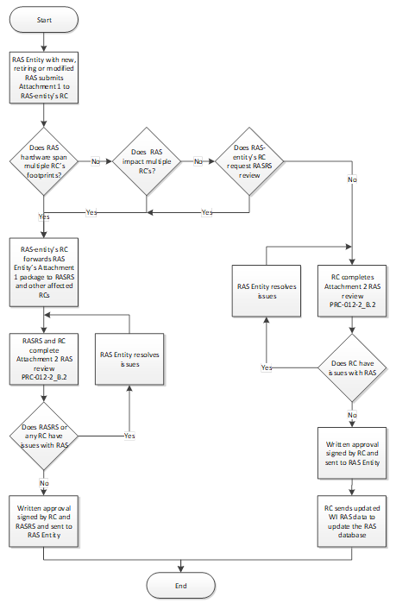

Design

Criteria | Applicable to this Criteria?  (Yes or No) | Notes
- The RAS actions satisfy performance objectives for the scope of events and conditions that the RAS is intended to mitigate.
- The designed timing of RAS operation(s) is appropriate to its BES performance objectives.
- The RAS arming conditions, if applicable, are appropriate to its System performance objectives.
- The RAS avoids adverse interactions with other RAS, and protection and control systems.
- The effects of RAS incorrect operation, including inadvertent operation and failure to operate, have been identified.
- Determination whether the RAS is limited impact. A RAS designated as limited impact cannot, by inadvertent operation or failure to operate, cause or contribute to BES Cascading, uncontrolled separation, angular instability, voltage instability, voltage collapse, or unacceptably damped oscillations.
- Except for limited impact RAS as determined by the RC, the possible inadvertent operation of the RAS resulting from any single RAS component malfunction satisfies all the following:
- The BES shall remain stable.
- Cascading shall not occur.
- Applicable Facility Ratings shall not be exceeded.
- BES voltages shall be within post-Contingency voltage limits and post-Contingency voltage deviation limits as established by the Transmission Planner and the Planning Coordinator.
- Transient voltage responses shall be within acceptable limits as established by the Transmission Planner and the Planning Coordinator.
- The effects of future BES modifications on the design and operation of the RAS have been identified, where applicable.

Implementation

Criteria | Applicable to this Criteria?  (Yes or No) | Notes
- The implementation of RAS logic appropriately correlates desired actions (outputs) with events and conditions (inputs).
- Except for limited impact RAS as determined by the RC, a single component failure in a RAS does not prevent the BES from meeting the same performance requirements as those required for the events and conditions for which the RAS is designed.
- The RAS design facilitates periodic testing and maintenance.
- The mechanism or procedure by which the RAS is armed is clearly described and is appropriate for reliable arming and operation of the RAS for the conditions and events for which it is designed to operate.

RAS Retirement

RAS retirement reviews should assure that there is adequate justification for why a RAS is no longer needed.

RC Reviewer Notes and Comments

Ref | Notes/Comments

Supporting Information

Operationally Affected Parties

Shared with the Public.

References

NERC Requirements | PRC-012
BA/TOP Operating Procedure
Other References

Version History

Version | Change | Date
1.0 | New checklist – Approved by Oversight Committee 9/17/20. | 1/01/21
1.1 | Periodic Review: No content changes, only minor formatting. | 1/18/24

Periodic Review Procedure

Review Criteria & Incorporation of Changes
There are no specific review criteria identified for this document.

Frequency
Review at least once every three (3) years.

